23 June 2020

Dear Parent/Carer

Virtual Transition Evenings

I write to give you advance notice that we plan to hold a series of virtual meetings using Zoom during the week commencing Monday 6 July. As we are unable to meet you in person, the purpose of these meetings will be to provide you with information about the academy and arrangements for the start of next term, as well as providing you with the opportunity to ask any questions you may have.

The meetings will be scheduled at the following times:

Tuesday 7 July - 6pm
Wednesday 8 July - 6pm and 7pm
Thursday 9 July - 6pm and 7pm

Next week we will write to you individually to confirm which meeting you have been invited to attend and provide details about how to access the meeting.

In the meantime if you have not returned your child’s admission form, please could I urge you to send it to us as soon as possible.

I look forward to seeing you in July.

Yours faithfully,
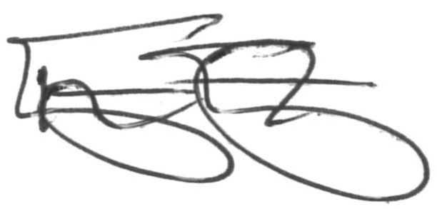
Mr T Eastaugh
Principal

