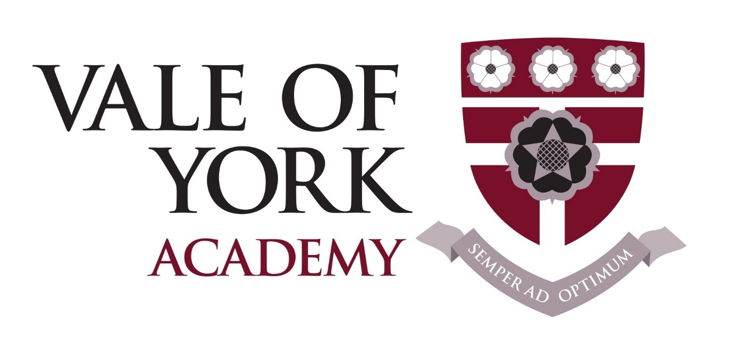

Equality Information and Objectives Policy

Date of issue: | September 2017
Policy review date: | September 2019
Policy status: | Statutory
Responsible member of SLT: | Helen Dowds

Contents:
Statement of intent
- Legislative framework
- Principles and aims
- Objectives
- Roles and responsibilities
- Gender reassignment
- Uniform/dress policy
- Curriculum
- Promoting equality
- Addressing prejudice related incidents
- Appeal process
- Monitoring and review

Statement of intent

Vale of York Academy recognises that certain groups in society have historically been disadvantaged on account of unlawful discrimination they have faced on the basis of their race, gender, disability, religion/belief, sexual orientation or age.

This policy will put in place a range of actions to eliminate prejudice, unlawful discrimination and victimisation within the school community and workforce.

Signed by:
 | Principal | Date:
 | Chair of governors | Date:

Legislative framework
  - This policy has due regard to statutory legislation including, but not limited to, the following:
- UN Convention on the Rights of the Child
- UN Convention on the Rights of Persons with Disabilities
- Human Rights Act 1998
- Special Educational Needs Regulations 2014
- Education and Inspections Act 2006
- Equality Act 2010
- The Equality Act 2010 (Specific Duties) Regulations 2011
  - The Equality Act 2010 provides a modern, single legal framework with three broad duties:
- Eliminate discrimination
- Advance equality of opportunity
- Foster good relations
  - Vale of York Academy fully understands the principles of the Act and the work needed to ensure that those with protected characteristics are not discriminated against and are given equal opportunities.
  - A protected characteristic, under the Act, is as follows:
- Age
- Disability
- Race, colour, nationality, ethnic or national origin
- Sex (including transgender people)
- Gender reassignment
- Maternity and pregnancy
- Religion and belief
- Sexual orientation
- Marriage and civil partnership (for employees)
  - The Act makes it unlawful for the responsible body of a school to discriminate against, harass or victimise a pupil or potential pupil:
- In relation to admissions.
- In the way it provides education for pupils.
- In the way it provides pupils access to any benefit, facility or service.
- By excluding a pupil or subjecting them to any other detriment.

Principles and aims
  - We see all learners and potential learners, and their parents and carers, as of equal value, regardless of their race, gender, disability, religion/belief, sexual orientation or age.
  - Our policies, procedures and activities must not discriminate but must nevertheless take account of differences of life-experience, outlook and background, and in the kinds of barrier and disadvantages which people may face in relation to their race, gender, disability, religion/belief, sexual orientation or age.
  - Vale of York Academy will promote race equality and have due regard to eliminate unlawful racial discrimination, promote equality of opportunity and promote good relations between people of different racial groups.
  - Vale of York Academy will promote disability equality throughout the school, ensuring the equality of opportunity, eliminating unlawful discrimination, eliminating disability related harassment and encouraging participation by disabled people in public life.
  - Vale of York Academy will promote gender equality by eliminating unlawful discrimination and harassment, and promote the equality of opportunity between men and women, girls and boys.
  - Transgender people are explicitly covered by the gender equality duty. For the purposes of this policy, the term ‘transgender’ refers to an individual whose gender expression or identity is different from that traditionally associated with the sex they were assigned at birth. This school will respect the confidentiality of those seeking gender re-assignment and will provide a supportive environment within the social community.
  - Vale of York Academy is opposed to all forms of prejudice and recognises that children and young people who experience any form of prejudice related discrimination may fare less well in the education system.
  - Vale of York Academy will ensure that all staff comply with the appropriate equality legislation and regulations.
  - The Vale of York Academy’s Admissions Policy will not discriminate in any way.

  - The school will:
- Ensure staff are aware of their responsibilities, are given necessary training and support, and report progress to the governing body.
- Ensure that the recording and reporting of equality and diversity is sufficiently scrutinised.
- Foster positive attitudes and relationships, and a shared sense of cohesion and belonging, and ensure this is promoted in our policies, procedures and activities.
- Observe good equalities practice in staff recruitment, retention and development, and ensure that all policies and procedures benefit all employees and potential employees regardless of their race, gender, disability, religion/belief, sexual orientation or age, and with full respect for legal rights relating to pregnancy and maternity.
- Reduce and remove inequalities and barriers that already exist.
- Engage with a range of groups and individuals to ensure that those who are affected by a policy, procedure or activity are consulted and involved in the design of new policies, and in the review of existing ones.
- Ensure that policies, procedures and activities benefit society as a whole, both locally and nationally, by fostering greater social cohesion, and greater participation in the public life of everyone, regardless of their race, gender, disability, religion/belief, sexual orientation or age.
- Ensure staff promote an inclusive and collaborative ethos in the school, challenging inappropriate language and behaviour, responding appropriately to incidents of discrimination and harassment, and showing appropriate support for pupils with additional needs, maintaining a good level of awareness of issues surrounding equalities.

Objectives
  - Whilst continuously aiming to improve the implementation of equality related policies and procedures, Vale of York Academy has established the following objectives:
- To monitor changes to the curriculum to ensure they result in good outcomes for pupils in all vulnerable groups, and to review the curriculum in light of new performance measures.
- To offer appropriate qualifications in English for pupils in all vulnerable groups.
- To implement effective strategies to support pupils in all vulnerable groups following linear exam courses.
- To improve the quality of support for pupils in all vulnerable groups in the classroom.
- To continue to explore the use of new technologies to support pupils in all vulnerable groups in accessing their learning. With special investigation taking place regarding the use of technology in modern foreign languages, internal exams and group work.

Roles and responsibilities
  - The governing body will:
- Ensure that the Vale of York Academy complies with the appropriate equality legislation and regulations.
- Meet its obligations under the Public Sector Equality Duty to publish equality objectives.
- Ensure that Vale of York Academy’s policies and procedures are developed and implemented with appropriate equality impact assessments informing future plans.
- Ensure that the recording and reporting of equality and diversity data is sufficiently scrutinised.
- Ensure that the Vale of York Academy’s Admissions Policy does not discriminate in any way.
- Ensure equal opportunities in its staff recruitment and promotion practices, professional development programmes and in membership of the governing body.
- Proactively recruit high-quality applicants from under-represented groups.
- Provide information in appropriate and accessible formats.
- Ensure that the necessary disciplinary measures are in place to enforce this policy.
  - The Principal will:
- Implement the policy and its procedures.
- Ensure that all staff members receive the appropriate equality and diversity training as part of their HR induction and continuous professional development.
- Ensure that all parents, visitors and contractors are aware of and are in compliance with the provisions of this policy.
- Actively challenge and take appropriate action in any case of discriminatory practice.
- Address any reported incidents of harassment or bullying in line with DfE guidance.
- Produce an annual report on the progress of implementing the provisions of this policy.
  - Employees will:
- Be mindful of any incidence of harassment or bulling in the school.
- Address any minor issues of harassment or bullying in the school and report any major breaches of the policy to the Principal.
- Identify and challenge bias and stereotyping within the curriculum and the school’s culture.
- Promote equality and good relations, and not harass or discriminate in any way.
- Monitor students’ progress and academic needs to ensure the appropriate support is in place.
- Keep up-to-date with equality legislation and its application by attending the appropriate training.
  - Students will:
- Not discriminate or harass any other pupil or staff member.
- Actively encourage equality and diversity in the school by contributing their cultural experiences and values.
- Report any incidences of bullying or harassment, whether to themselves or to others, to the Progress Leader or to another member of the school staff.
- Abide by all the school’s equality and diversity policies, procedures and codes.
  - Vale of York Academy will have an equality page on its website, in order to demonstrate how it is complying with the Public Sector Equality Duty in the Equality Act 2010, and advancing equality of opportunity.

Gender reassignment
  - The Act ensures legal protection against discrimination (direct or indirect) for everyone under the nine protected characteristics mentioned previously, including gender reassignment.
  - A person has the protected characteristic of gender reassignment if that person is proposing to undergo, is undergoing or has undergone a process (or part of a process) for the purpose of reassigning the person’s sex by changing physiological or other attributes of sex.
  - All members of staff and pupils have a right to privacy, which includes the right to keep one’s transgender status confidential. School staff should not disclose information that may reveal a child or other staff member’s transgender status.
  - The school will appoint a staff member in whom any transgender child can confide and who can deal with any issues that may arise, for instance bullying or harassment.
  - A glossary of terminology related to the transgender field can be found on the Gender Identity Research and Education Society Website.

Uniform/dress policy
  - The Act does not deal specifically with school uniform or other aspects of appearance, such as hair colour and style, and the wearing of jewellery and make-up, but the general requirement not to discriminate in the treatment of pupils applies here in relation to other aspects of the school policy.
  - Vale of York Academy will ensure that blanket uniform policies do not discriminate because of race, gender, disability, religion/belief, sexual orientation or age.
  - Vale of York Academy will be sensitive to the needs of different cultures, races and religions and act reasonably in accommodating these needs, without compromising important school policies, such as school safety or discipline.

Curriculum
  - All pupils will be entitled to access to a curriculum and to teaching and learning opportunities which meet their needs, including extra support where this has been identified as a statutory need. When planning the curriculum, the school will take every opportunity to promote and advance equality.
  - The school will develop an appropriate 11-18 curriculum for all pupils in all vulnerable groups.

Promoting equality
In order to meet our objectives, the school has identified the following priorities:

  - Vale of York Academy will provide auxiliary aids that are directly related to disabled children’s educational needs as a reasonable adjustment so they can integrate wholly in all parts of school life.
  - Staff will ensure that all pupils are able to take part in extra-curricular activities and residential visits, and the school will monitor uptake of these visits to ensure no one is disadvantaged on the grounds of a protected characteristic.
  - Vale of York Academy will ensure that all forms of prejudice-motivated bullying is taken seriously and dealt with equally and firmly.
  - There will be differential schemes of work designed to meet the abilities and learning styles of all pupils.
  - There will be a clearly defined disciplinary system, which will be consistently enforced.
  - The school will increase access for disabled children and young people to the school curriculum and will take necessary steps to meet pupils’ needs by using a variety of approaches and planning reasonable adjustments for disabled pupils, enabling our pupils to take as full a part as possible in the activities of the school.
  - The school will ensure there is adequate access to the physical environment of the school.
  - The school will improve the delivery of written information to disabled children and young people.
  - The school will seek the views of advisory staff, outside agencies and local schools.
  - Throughout the year, the school will plan on-going events to raise awareness of equality and diversity.
  - The school will consult with stakeholders, i.e. pupils, parents/carers, staff and relevant community groups, to establish equality objectives and draw up a plan based on information collected on protected groups and accessibility planning. These equality objectives will be reviewed and reported on annually.
  - Bullying and prejudice will be carefully monitored and dealt with accordingly. Regular training will be given to both existing and new staff to ensure that they are aware of the process for reporting and following up incidents of prejudice-related bullying.

Addressing prejudice related incidents
  - Vale of York Academy is opposed to all forms of prejudice and we recognise that pupils and staff who experience any form of prejudice related discrimination may fair less well in the education system.
  - The school will ensure that pupils and staff are aware of the impact of prejudice in order to prevent any incidents from occurring.
  - If incidents still occur, the school will address them immediately and report them to the LA.

Appeal process
  - Staff members retain the right to appeal against a decision on the acceptability of their appearance using Vale of York Academy’s grievance procedure.

Monitoring and review
  - Vale of York Academy will review this policy annually via the Principal, to ensure that all procedures are up-to-date.
  - The policy will be monitored and evaluated by the Principal and governing body in the following ways:
- Individual attainment data
- Equal opportunities recruitment data
- Equality impact assessments
- Ofsted inspection judgements on equality and diversity
- Incident records related to harassment and bullying
  - Any changes made to this policy will be communicated to all members of staff.

